№
01 | 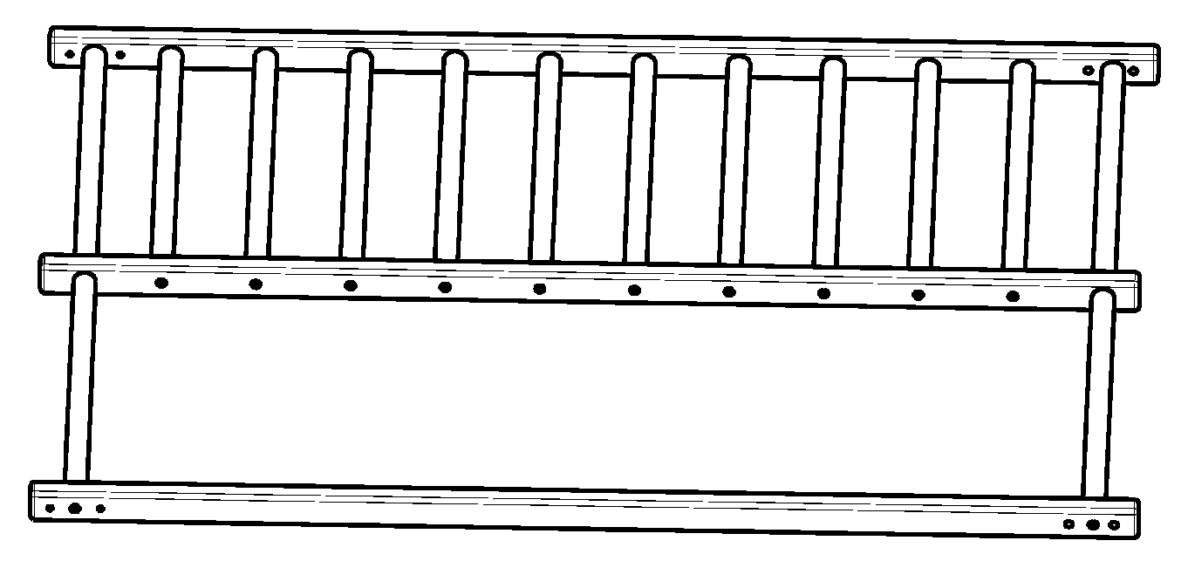 | 1 | 11 | 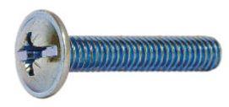6x40 | 8
02 | 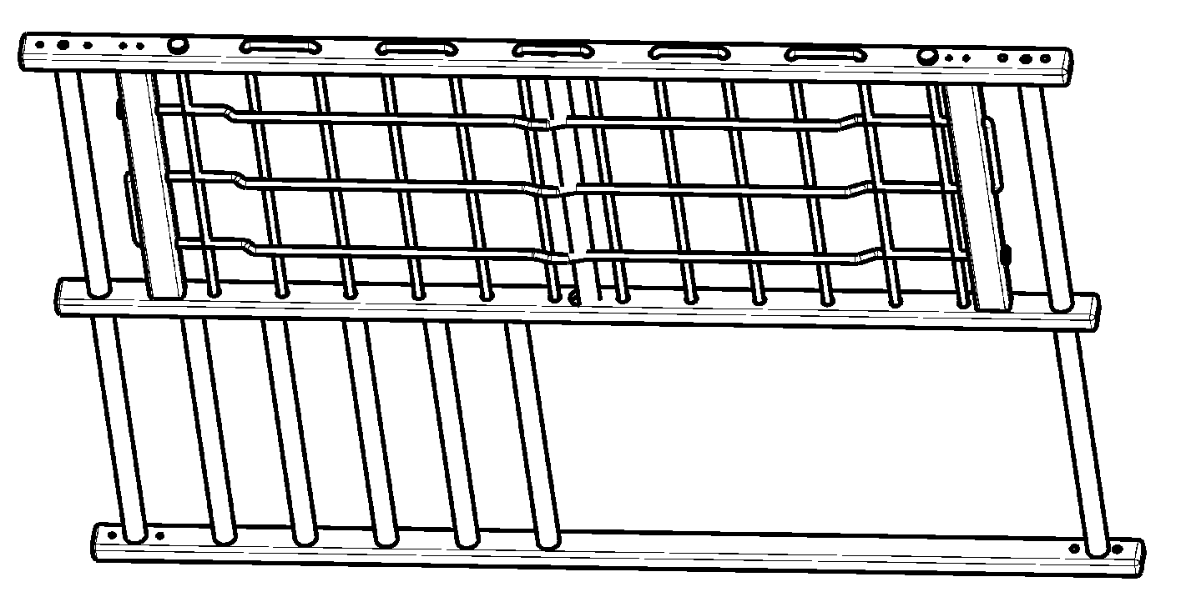 | 1 | 12 |  | 8
03 | 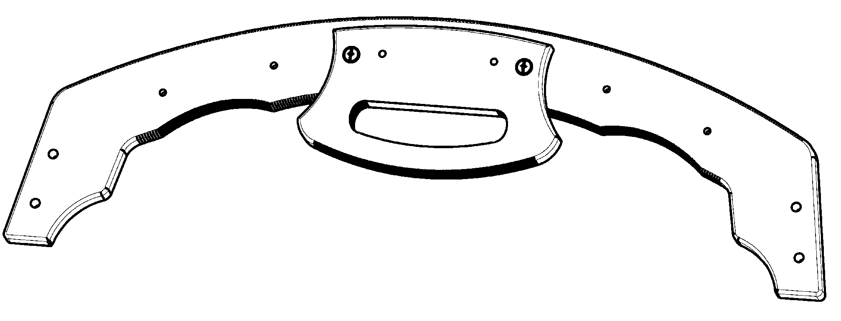 | 2 | 13 | C8 | 8
04 | 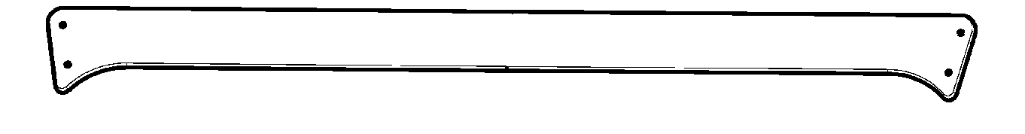 | 2 | 14 | C6 | 12
05 | 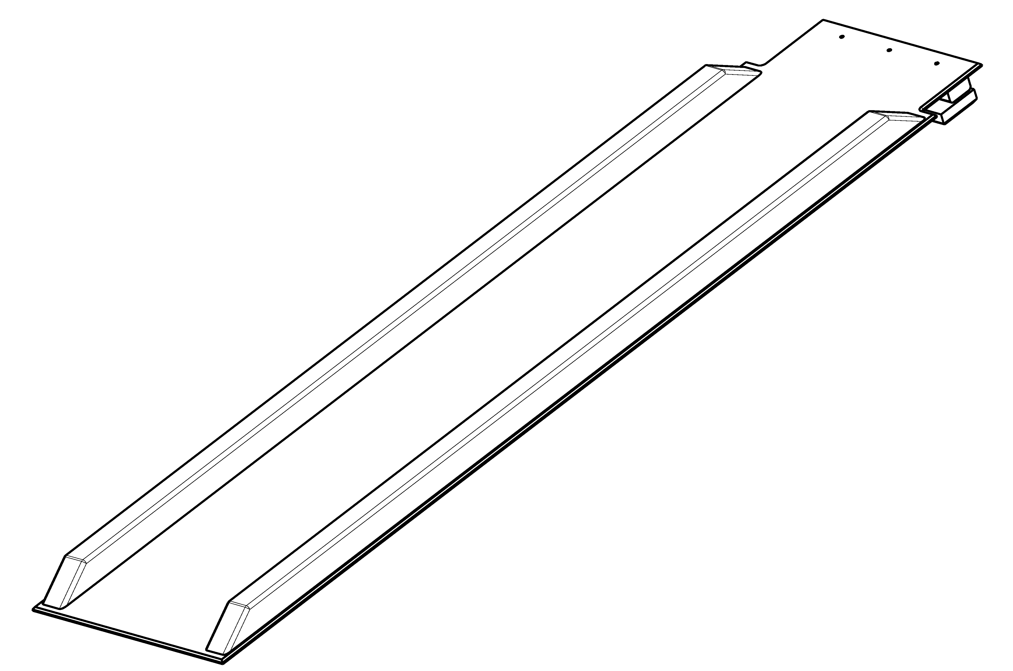 | 1 | 15 |  | 12
06 | 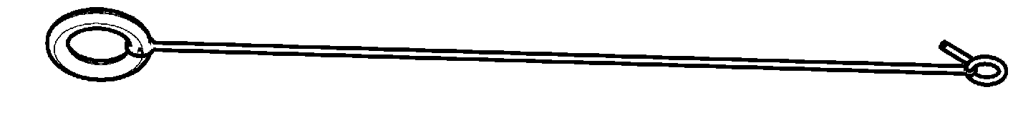 | 2 | 16 | 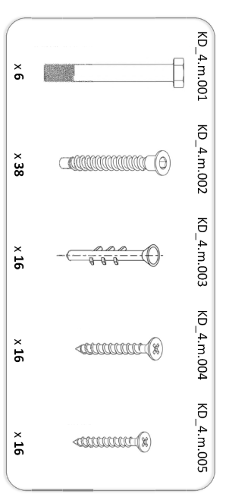6,3x50 | 12
07 | L= 840 | 6 | 17 | 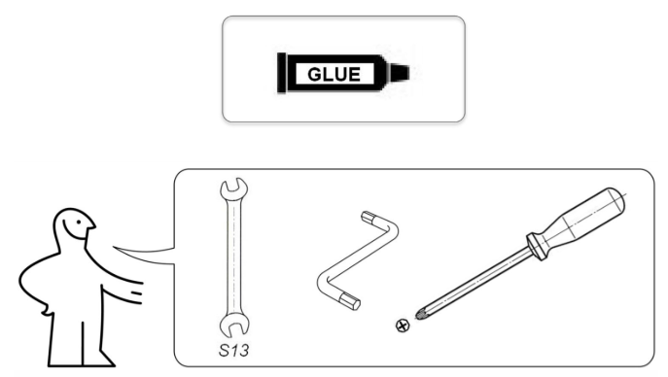 | 1
08 | 8x55 | 4 | 18 |  | 1
09 | M8 | 4 | 18 |  | 1
10 | 6x50 | 4 | 19 |  | 1/  ???

07

03
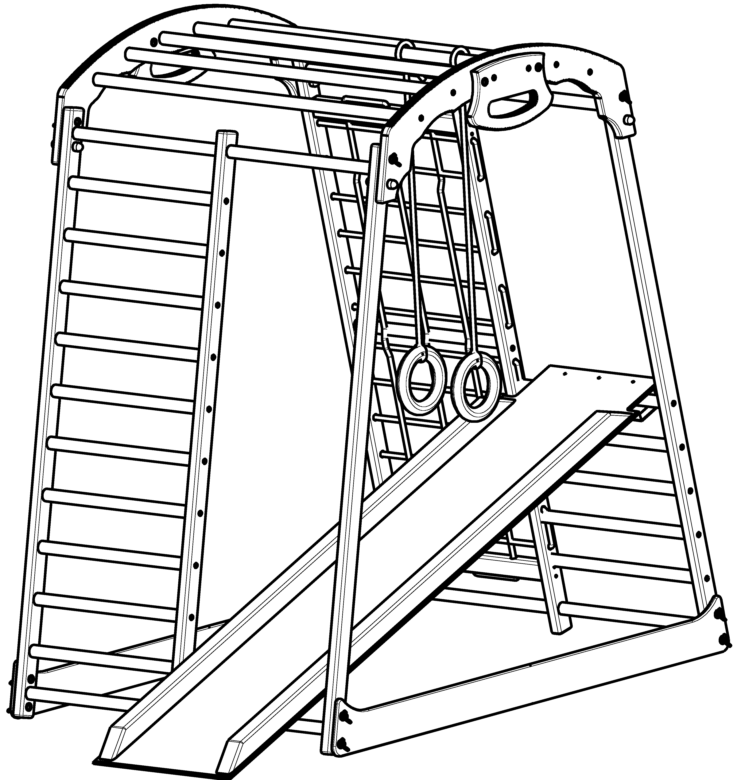

06

02

04
01
05

1

I
II
16
14
14
14
07
15
15
15
10
10
10
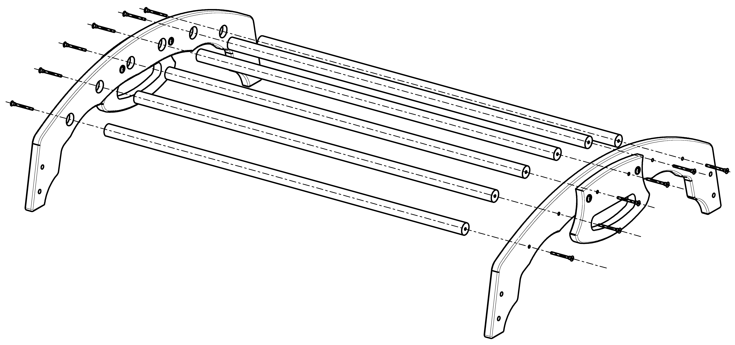
14
17
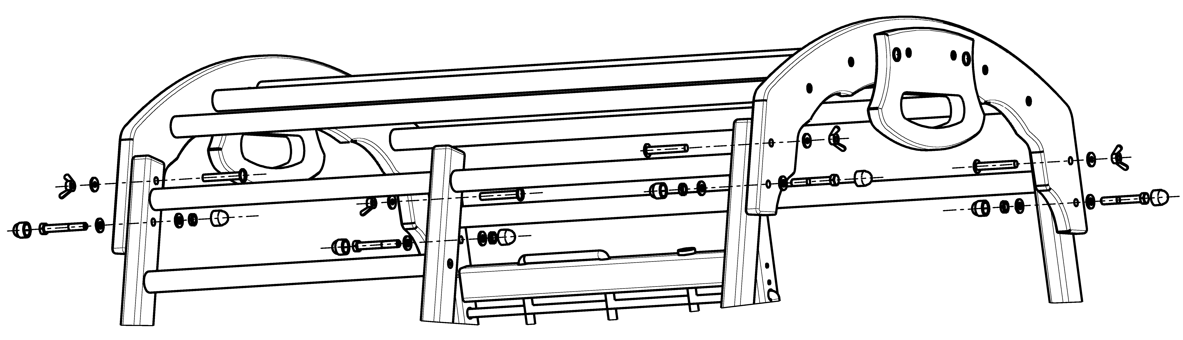
15

03
08
08
09
09
16
03
08
08
12
12
09
09
12
12
III
12
12
13
13
12
12
13
13
13
13
13
13

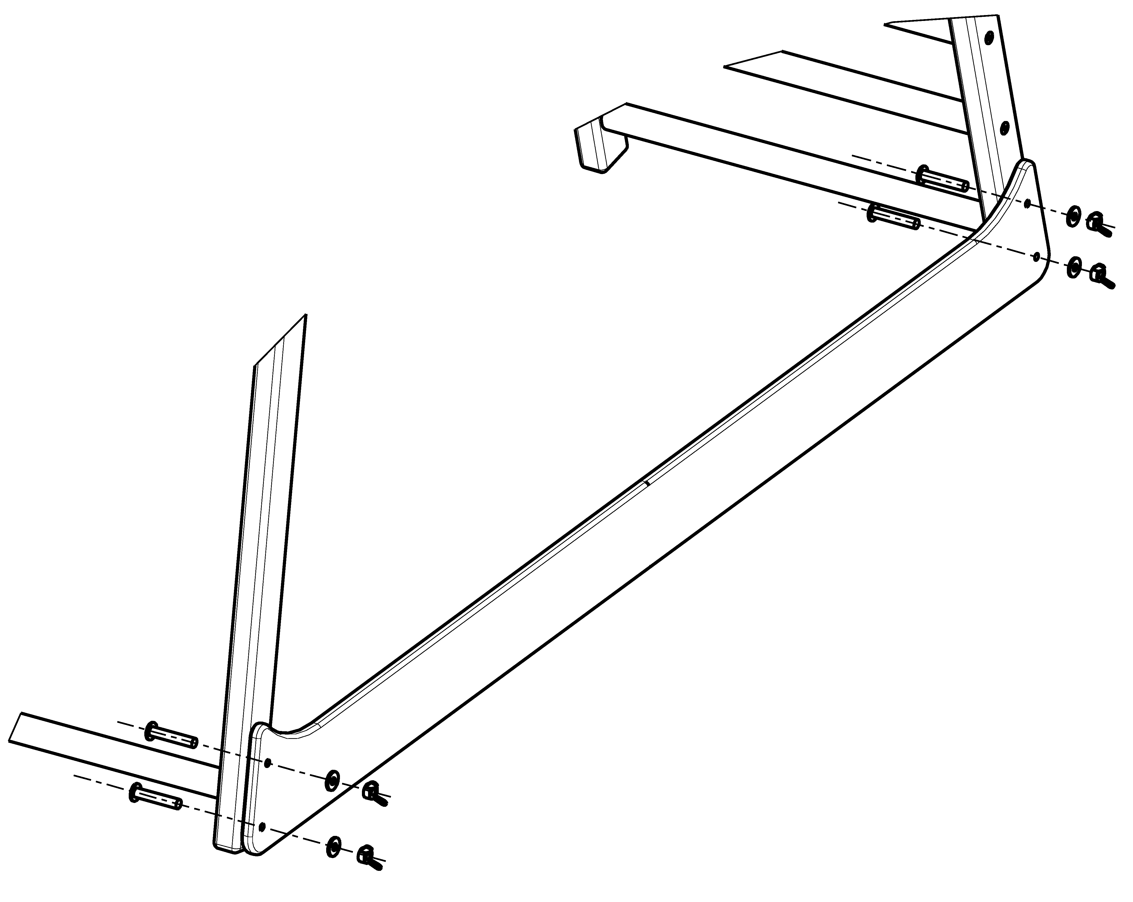
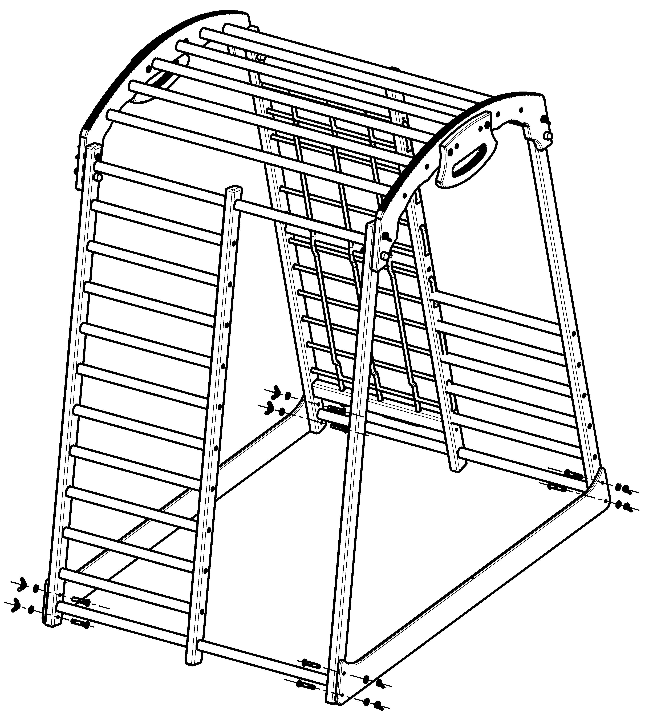

11
02

01
14
15
11

04

14
15

2

