№
01 |  | 1 | 12 | 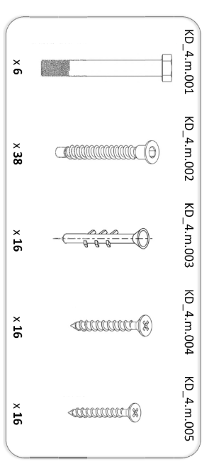8x55 | 4
02 |  | 1 | 13 |  | 8
03 |  | 1 | 14 | M8 | 4
04 |  | 1 | 15 | C8 | 8
05 | 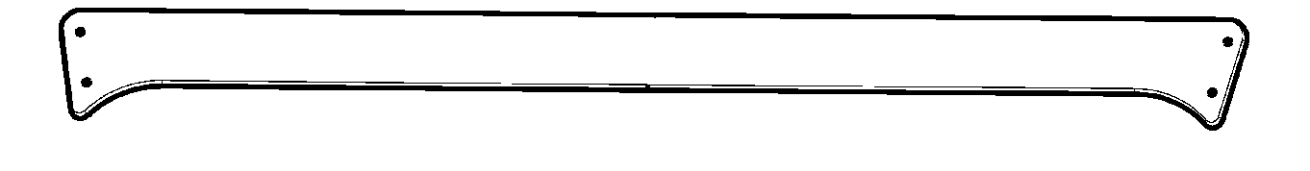 | 2 | 16 | C6 | 12
06 |  | 2 | 17 |  | 12
07 | L= 400 | 16 | 18 | 6,3x50 | 26
08 | L= 1190 | 4 | 19 | 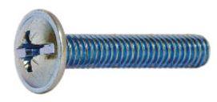6x40 | 12
09 | 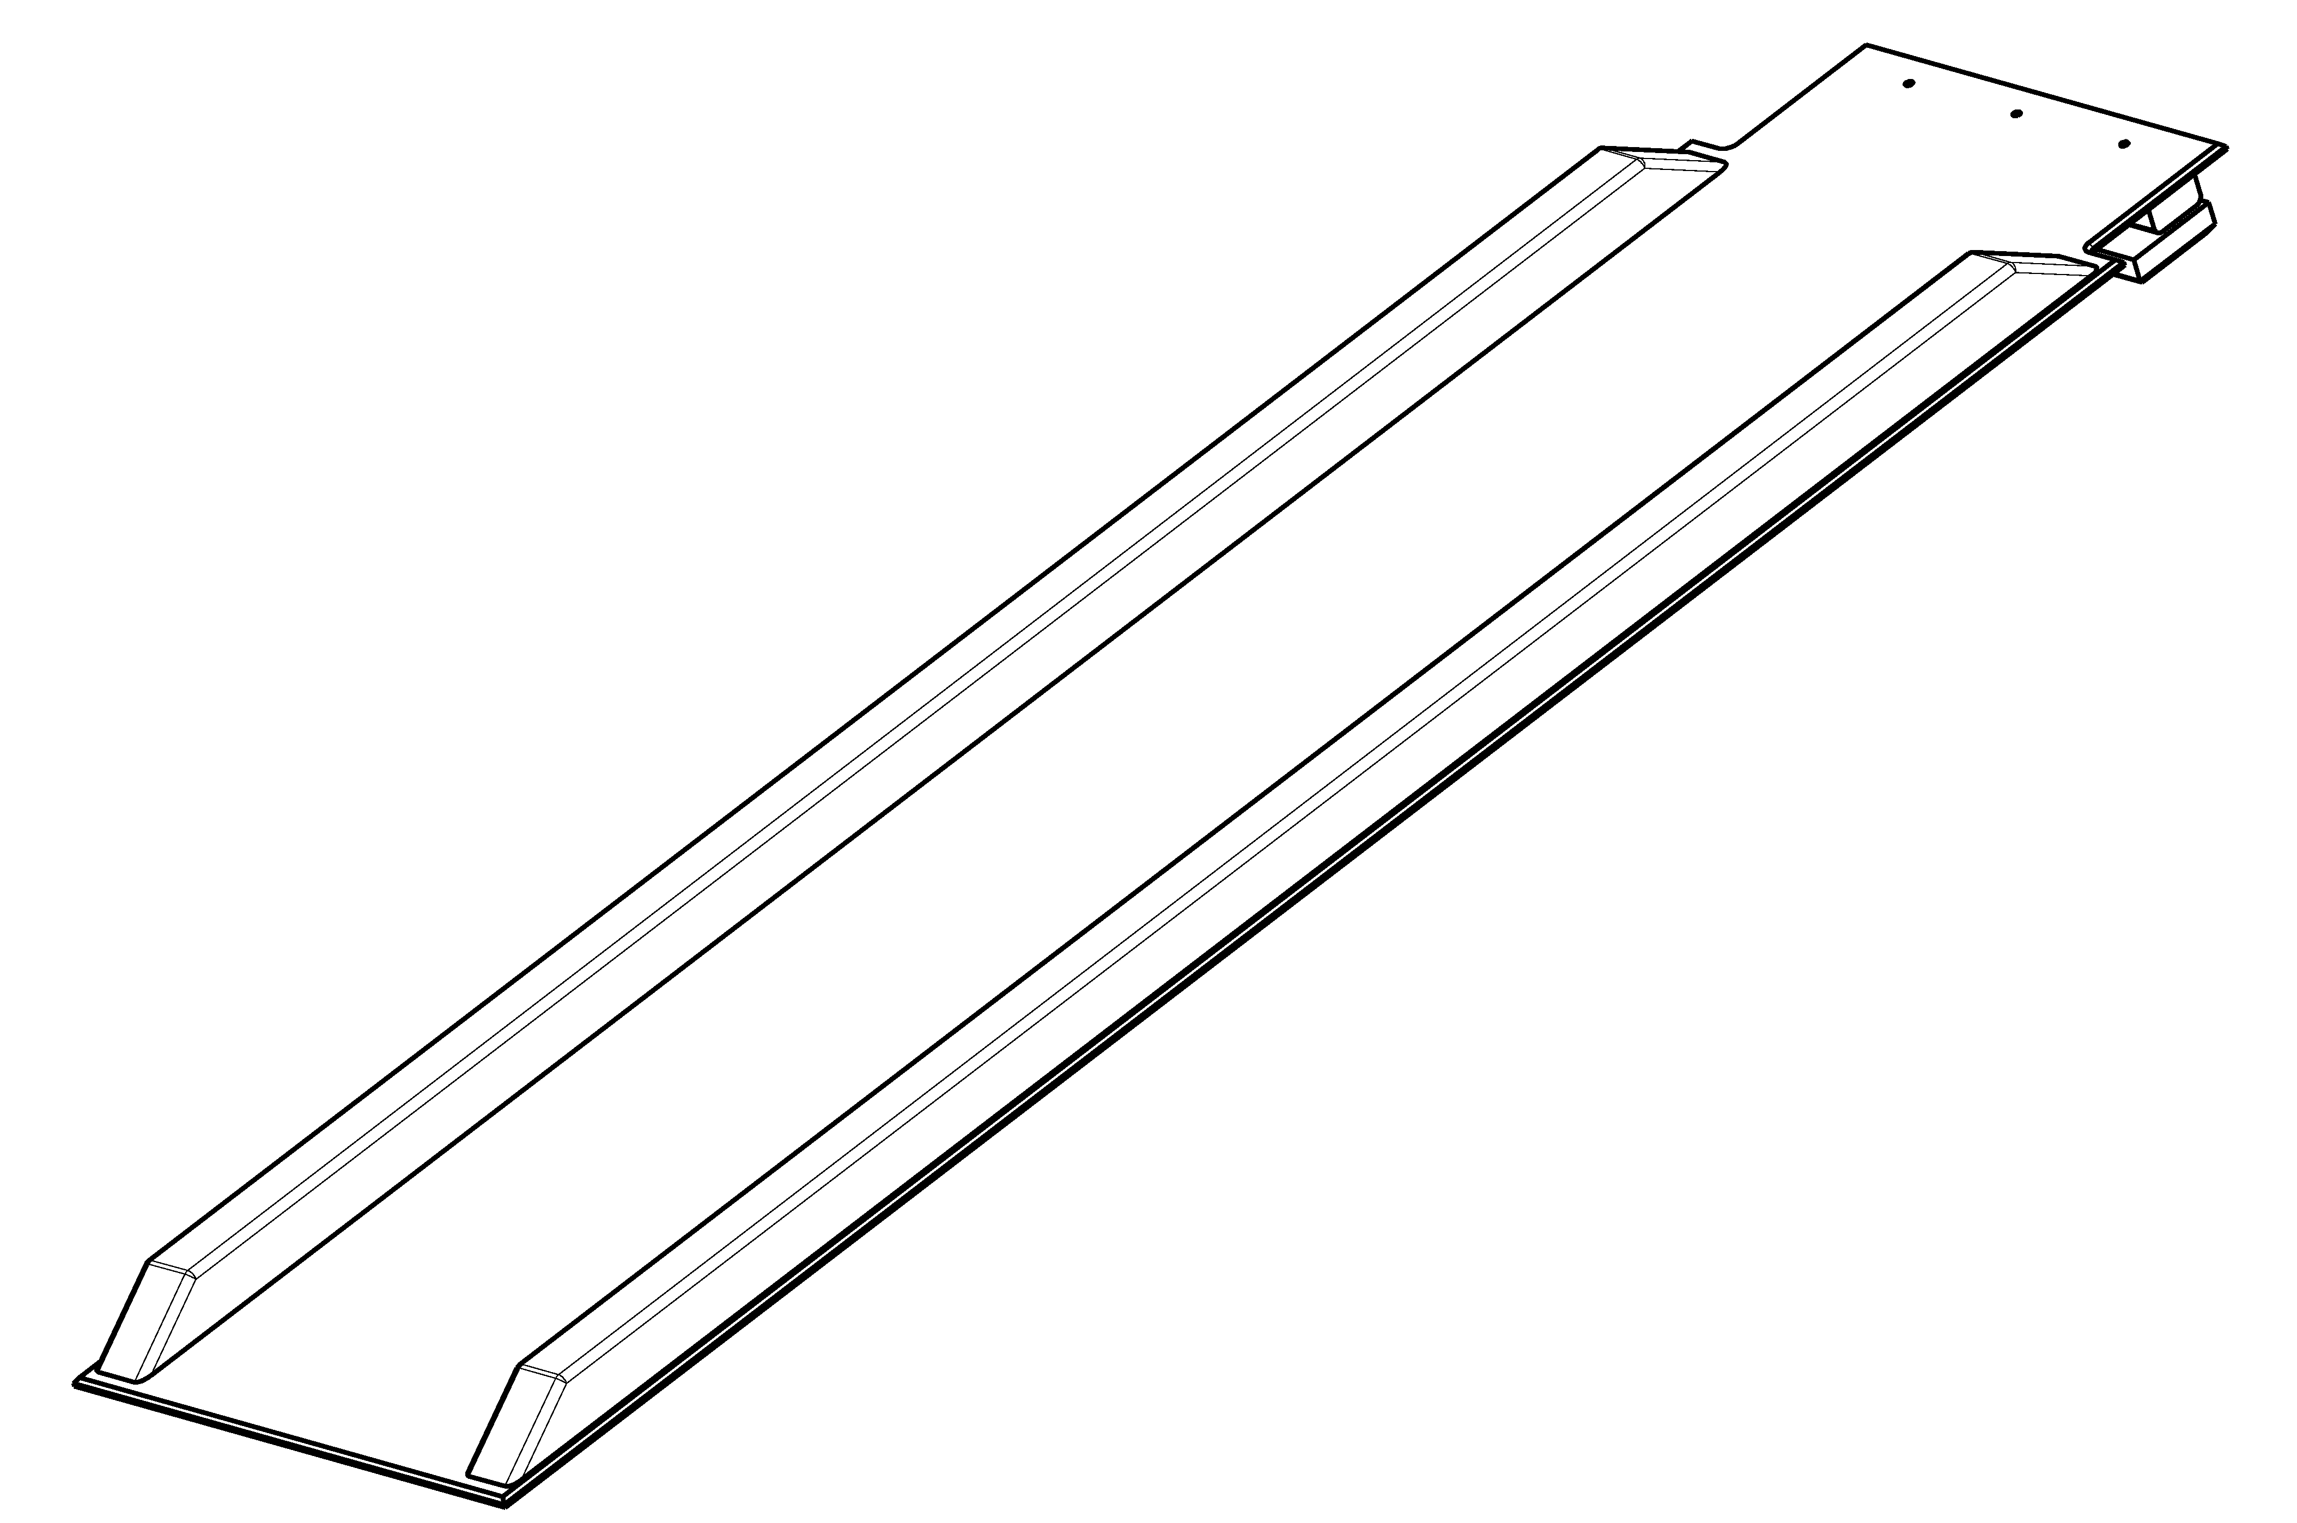 | 1 | 20 | 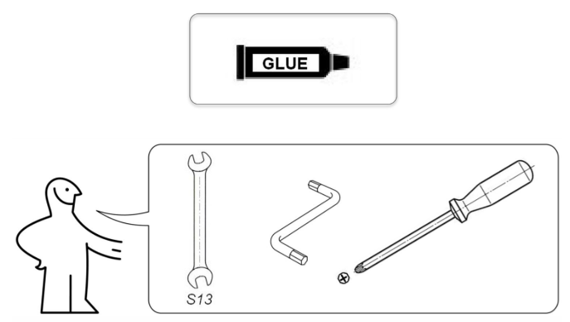 | 1
10 | 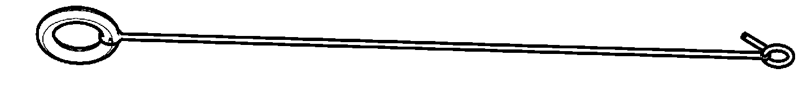 | 2 | 21 |  | 1
11 |  | 2 | 22 |  | 1/

03
08
06
07
11

04

01

05
10
02
09

1
I
II
08
18
18
08

01
04
20

02
07

03
20
18
08

18
III
08
07
IV
18

18
III
20
11

20

18
11

06
06
18

2

V
16
13
14
IV
16
13
14
17
19
15
19
17
15

12
12
13
19
13
15
II
15
I
19

VI
V
19
16
17

05
19
16
17
3

